On October 2, 1968, more than 300 students and workers at La Plaza de las Tres Culturas in Tlatelolco, Mexico City were gunned down by police, on the order of former President Luis Echeverria. Those that lost their lives were protesting against the staging of the Olympic Games in a country that was struggling with poverty and an endemic lack of funding in vital public services such as education and healthcare. Often referred to as Mexico’s Tiananmen Square, the incident nevertheless went largely ignored by the Olympic Movement, who took the stance that the Olympic Games should never be affected by politics, and thus would not affect any decision to continue with the staging of the Games.

Mired by controversy before it had even begun, the Mexico 1968 Summer Games continued to court controversy via what became arguably the most overt display of racial protest in any sports event in history: The Black Power Salute of Tommie Smith and John Carlos. An account of the Mexico Games commences this case study, and kicks off consideration of issues of race and ethnicity in the Olympic Games. It is followed by presentation of the events of the Berlin Games (Hitler’s treatment of Jews and his associated use of the Olympic Games as a tool of legitimisation and propagandisation), the Munich Games (massacre of Israeli athletes by Palestinian terrorists), and the Max Schmeling vs Joe Louis match and re-match.
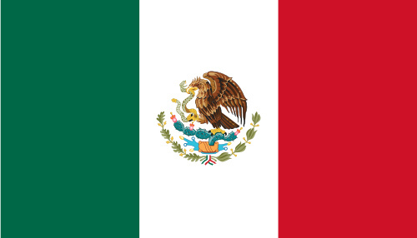
Image created by Vibracobra23 and reproduced under a Creative Commons licence.

The 1968 Mexico Games and The Olympic Project for Human Rights
The Mexico Olympics courted controversy for two reasons: the first reason was the aforementioned massacre of Mexican protestors, and the second was The Black Power Salute, which came to be recognised as one of the most powerful racial protests ever made at a sporting event.

The Black Power Salute
The black power salute was a protest made by US Olympic athletes Tommie Smith and John Carlos, gold and bronze medallists in the 200m event, on the Olympic podium. After receiving both medals, both athletes stood with their heads bowed and a black-gloved hand raised as the American National Anthem began to play. The athletes remained in this pose for the duration of the national anthem. As they left the podium at the end of the ceremony they were booed by many in the crowd.

Following the protest, seven-time World record holder Tommie Smith told a press conference: "If I win I am an American, not a black American. But if I did something bad then they would say 'a Negro'. We are black and we are proud of being black. Black America will understand what we did tonight."

Smith explained the details of the protest: his right fist had represented black power in America, while the left fist of his teammate Carlos had represented black unity. Together they formed an arch of unity and power. The black scarf that he wore represented black pride, and his black socks, worn without shoes on his feet, symbolised black poverty.

The International Olympic Committee was quick to condemn the actions of the athletes. An IOC spokesperson stated that the protest was "a deliberate and violent breach of the fundamental principles of the Olympic spirit." The two athletes were subsequently expelled from the Olympics and had their medals taken away from them. They never raced for the US national team again.

The Olympic Project for Human Rights
The protest itself formed part of the Olympic Project for Human Rights (OPHR). Professor Harry Edwards (a now-retired Professor of Sociology at Berkeley) led the movement, the specific purpose of which was to boycott the 1968 Summer Olympics as a means of protest against racism in the USA. Despite public criticism, personal threats and FBI surveillance, Edwards and the OPHR successfully led a number of sports boycotts. The Black Power Salute at the 1968 Games was undoubtedly a major landmark in the history of the OPHR that drew consciousness towards the issues associated with racial discrimination in the USA.

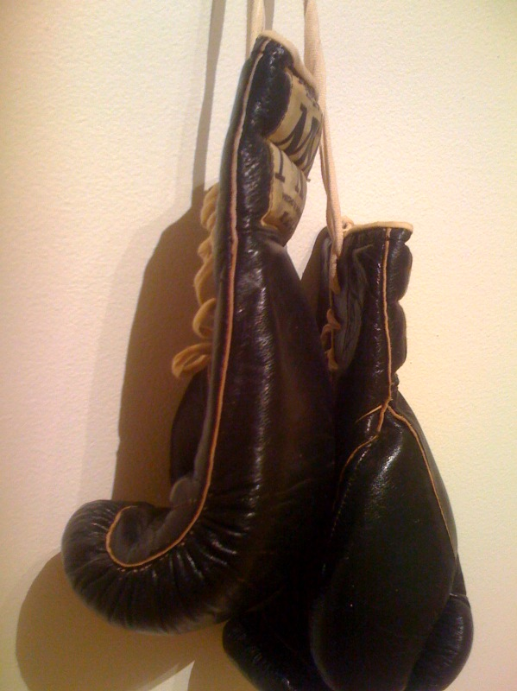
Image created by Todd Huffman and reproduced under a Creative Commons licence.

Max Schmeling v Joe Louis
Whilst racial segregation still dominated the racial landscape of the USA during the 30’s, professional boxing had become one of the few integrated sports in the United States at that time. Prizefighter Joe Louis was a hero to American Blacks. On June 19, 1936, after rain postponed the fight a day, the undefeated Louis was knocked out by Germany's Max Schmeling. Although not an Olympic event, the fight took place alongside a backdrop of the 1936 Berlin Olympic Games, and thus often features within sporting conversations surrounding that era, particularly with regard to considerations of Hitler’s use of sport at that time as a means to progress the concept of Aryan supremacy.
Tommie Smith - "It is very discouraging to be in a team with white athletes. On the track you are Tommie Smith, the fastest man in the world, but once you are in the dressing rooms you are nothing more than a dirty Negro."

German Minister of Propaganda Joseph Goebbels was quick to proclaim Schmeling's victory a triumph for Germany and for the principles of Aryan supremacy: "Schmeling's victory was not only sport. It was a question of prestige for our race." However, in a 1938 rematch, Louis defeated Schmeling in one round.

Despite the political and ideological competition that the fight represented, the two men were always friends, and remained so throughout their lives.

The Berlin Olympics
The Berlin Summer Olympic Games of 1936 allowed the world its first comprehensive insight into the propagandised war machine that was Hitler’s Third Reich. The Leni Reifenstahl film Olympia provides an enduring record of such propaganda.

The Berlin Olympic Games were certainly a propaganda victory for Hitler, hiding anti-Semitic activity for the duration of the Games and taking steps to portray Germany as a respectable member of the international community. Anti-Jewish signs were removed from public display and violence towards Jews was minimised throughout the duration of the event. Whilst overt, outward displays of anti-Semitism were kept to a minimum in this Olympic period, it would be a mistake to conclude that discriminatory activity did not continue. Furthermore, it would be a mistake to believe that such a lack of overt evidence of anti-Semitism explained the decision of many nations not to boycott the Games. Many nations were in fact painfully aware, by this point, that there had been a rise in anti-Semitism preceding the period before the Games.

Considerations of a Boycott
Soon after Hitler took power in 1933, observers in the United States and other western democracies questioned the morality of supporting Olympic Games hosted by the fascistic Nazi regime. In the same year, Avery Brundage, then President of the American Olympic Committee, stated that: “The very foundation of the modern Olympic revival will be undermined if individual countries are allowed to restrict participation by reason of class, creed, or race.” Brundage initially considered the move of the Games from Germany to another venue, but later restated his position as being content with Berlin. This was based mostly on his brief and tightly managed inspection of German sports facility, after which he concluded that Jews were being treated fairly.
Image created by Mamjodh and reproduced under a Creative Commons licence.

That same year, the American Jewish Congress, the Jewish Labor Committee and the Anti-Nazi League staged mass rallies to protest against Nazi persecution of Jews and other ethnic groups. These groups supported the boycott of the 1936 Games as part of a wider general boycott of German goods.

By the end of 1934, Brundage was vocal in his opposition to a boycott, of the Berlin Games, arguing that sport was apolitical. “The Olympic Games belong to the athletes and not to the politicians.” Brundage further stated that American athletes should not become involved in “the present Jew-Nazi altercation.”
“Neither Americans nor the representatives of other countries can take part in the Games in Nazi Germany without at least acquiescing in the contempt of the Nazis for fair play and their sordid exploitation of the Games.” - Ernest Lee Jahncke, American member of the IOC, in a letter to Count Henri Baillet-Latour, President IOC, November 25, 1935.
By 1935, Brundage was alleging the existence of a “Jewish-Communist conspiracy” to keep the United States out of the Olympic Games. Brundage's main American rival in discussions over a possible US boycott was Judge Jeremiah Mahoney, then President of the Amateur Athletic Union. Mahoney believed that Germany had contravened Olympic rules that forbade discrimination the grounds of race and religion, and was particularly concerned that engagement in the Games might at the same time be seen as an endorsement of Hitler's Third Reich.

Judge Mahoney was not alone in his protestations. At the time, the Catholic journal The Commonwealth (November 8, 1935) advised boycotting the Berlin Olympic Games to avoid a move that it viewed would “set the seal of approval upon the radically anti-Christian Nazi doctrine of youth.”

Individual Jewish athletes across Europe and the US were to also make a stand. Milton Green, Captain of the Harvard University track team, took first place in the 110-meter high hurdles in regional US pre-Olympic trials, but symbolically declined his place. His Jewish teammate Norman Cahners also joined him in declining his place as a means of boycotting the Games.

The concept of Aryan Supremacy and ethnic genocide meted out by the Nazi Thirds Reich was not, of course, limited to Jewish people. The International Olympic Committee had to assure the safety of black athletes at the Games, and some black journalists argued that athletic victories by Blacks would undermine Nazi racial views of Aryan supremacy. Of course, they were right if we are to observe the effect of Jesse Owens on Hitler’s propaganda machine.

The IOC Position on Calls for a Boycott
Ernest Lee Jahncke, a former assistant secretary of the Navy, was expelled from the International Olympic Committee (IOC) in July 1936 after adopting a strong public stand against the Berlin Games. The IOC, perhaps symbolically, elected Avery Brundage to fill his seat. Jahncke remains the only member in the 100-year history of the IOC to be ejected in this way. The Games were to go ahead with all countries in attendance.

The Munich Massacre

Case Study: European Maccabi Games 2007
20th Century aanti-Semitic sentiments have no doubt contributed to the development of Jewish sports events, such as the Maccabi Games. The quadrennial Maccabi Games, held in Israel, are organised by the Maccabi World Union (MWU). The MWU organises six regional games and one international game that together play host to Jewish athletes from fifty countries across five continents. These regions comprise Israel, Europe, North America, Latin America, South Africa and Australia. The World Maccabi Games are recognized by the International Olympic Committee as the third largest sports event in the world.
The first ever European Maccabi Games were held in Prague in 1929 and Antwerp in 1930. The Games were postponed for a number of years around the period of WWII, an event that decimated the global Jewish population and led to the formation of the nation state of Israel in the Middle East. The next Games were subsequently postponed until 1959, where they were hosted successfully in Copenhagen, followed by Lyon (1963), Leicester (1979), Antwerp (1983), Copenhagen (1987), Marseille (1991), Amsterdam (1995), Glasgow (1999), Antwerp (2003) and Rome (2007).
The philosophy behind the Games is to promote sport as a lifestyle, as an essential instrument in youth education, and in the promotion of wholesome social values. The Games aim to bring together Jews from different cultures, all united by the common religious matrix of Judaism, uniting the Jewish diaspora in one great sporting event.
“They're all gone.” Those were the words of ABC journalist Jim McKay, uttered at 3am, 5th September 1972. With tears in his eyes,

McKay reported that 11 Israeli athletes had been murdered by terrorists in a day long siege that had played out against the backdrop of the 1972 Munich Games. The event represented the first time that Germany had staged the Games since the Nazi atrocities that had taken place against the Jewish people before and during WWII.

The murders were carried out by a Palestinian terrorist group called Black September, who had taken the Israeli athletes hostage in order to demand the release of Palestinian prisoners from Israeli jails. German authorities were heavily criticised for their handling of the crisis, including the fact that security surrounding the Olympic Village had been unacceptably lax.

The massacre of these 11 Israeli athletes was not considered sufficiently serious to merit the cancellation or even substantial postponement of the Games by the IOC. This prompted Jim Murray of the Los Angeles
Times to comment that “Incredibly, they're going on with it,” Murray went on to comment: “It's almost like having a dance at Dachau.”

The events of the Munich Games have most recently been captured in the Steven Spielberg film Munich, and in the docudrama One Day in September.

FIND OUT MORE
The Olympic Project for Human Rights: An Assessment Ten Years Later. Black Scholar, v10 n6-7 p2-8 Mar-Apr 1979
The Revolt of the Black Athlete Harry Edwards, (New York: the Free Press, 1970)
Berlin Games: How the Nazis Stole the Olympic Dream. Guy Walters (2007). Harper Perennial.

Olympics website:
www.olympics.org

CREDITS
© Oxford Brookes University 2010. oxb:060111:014cs

This resource was produced as part of the 2012 Learning Legacies Project managed by the HEA Hospitality, Leisure, Sport and Tourism Subject Centre at Oxford Brookes University and was released as an Open Educational Resource. The project was funded by HEFCE and part of the JISC/HE Academy UKOER programme. Except where otherwise noted above and below, this work is released under a Creative Commons Attribution only licence.

Exceptions to the Licence
The name of Oxford Brookes University and the Oxford Brookes University logo are the name and registered marks of Oxford Brookes University. To the fullest extent permitted by law Oxford Brookes University reserves all its rights in its name and marks, which may not be used except with its written permission.

The JISC logo is licensed under the terms of the Creative Commons Attribution-Non-Commercial-No Derivative Works 2.0 UK: England & Wales Licence. All reproductions must comply with the terms of that licence.

The Higher Education Academy logo and the HEA Hospitality, Leisure, Sport and Tourism Subject Centre logo are owned by the Higher Education Academy Limited and may be freely distributed and copied for educational purposes only, provided that appropriate acknowledgement is given to the Higher Education Academy as the copyright holder and original publisher.



Reusing this work
To refer to or reuse parts of this work please include the copyright notice above including the serial number. The only exception is if you intend to only reuse a part of the work with its own specific copyright notice, in which case cite that.

If you create a new piece of work based on the original (at least in part), it will help other users to find your work if you modify and reuse this serial number. When you reuse this work, edit the serial number by choosing 3 letters to start (your initials or institutional code are good examples), change the date section (between the colons) to your creation date in ddmmyy format and retain the last 5 digits from the original serial number. Make the new serial number your copyright declaration or add it to an existing one, e.g. ‘abc:101011:014cs’.

If you create a new piece of work or do not wish to link a new work with any existing materials contained within, a new code should be created. Choose your own 3-letter code, add the creation date and search as below on Google with a plus sign at the start, e.g. ‘+tom:030504’. If nothing comes back citing this code then add a new 5-letter code of your choice to the end, e.g.; ‘:01lex’, and do a final search for the whole code. If the search returns a positive result, make up a new 5-letter code and try again. Add the new code your copyright declaration or add it to an existing one.

